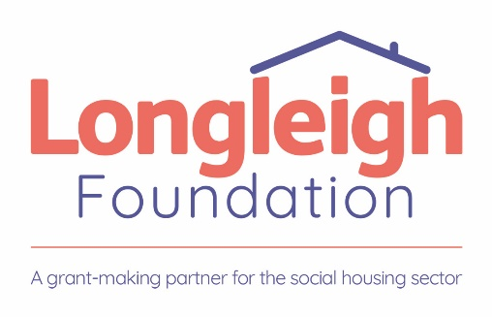

Response document

Contact details and declaration

I declare that to the best of my knowledge the answers submitted and information contained in this document are correct and accurate.

Contact details and declaration
Contact name
Name of organisation
Role in organisation
Phone number
E-mail address
Postal address
Signature (electronic is acceptable)
Date

Submission – (please note no word count restrictions but please be succinct. Response boxes will expand as required)

- Organisational Experience & Expertise

Please include in your response, an overview of your organisation’s experience in delivering financial wellbeing services, examples of working with social housing residents or vulnerable communities, and what qualifications and experience your team members hold, who will be delivering this service.

Response

- Service Delivery & Approach

Please include in your response how you will ensure accessibility and engagement with social housing residents, your approach to triaging clients and conducting financial wellbeing assessments and what engagement methods you will use to support clients.

Response

- Financial Resilience Support

Please include in your response what tools and strategies you will use to help clients with budgeting and financial planning, how will you support clients with income maximisation and benefits advice, what level of debt advice you can provide (e.g., negotiation with creditors, insolvency advice) and how you will assist clients in securing sustainable employment?

Response

- Monitoring, Evaluation & Reporting

Please include in your response what systems you have in place to track and report on financial gains, employment outcomes, and client engagement and please provide examples of impact reports or previous outcomes from similar projects. Please explain how will you ensure that client data is recorded securely and used effectively for service improvements in line with GDPR?

Response

- Collaboration & Promotion

Please include in your response how you will build effective relationships with Stonewater staff / referral partners and what strategies you will use to raise awareness of the service among potential clients?

Response

- Sustainability & Innovation

Please include in your response how you will ensure that clients develop long-term financial resilience beyond their engagement with the service? Do you have any innovative approaches or tools that could enhance service delivery? And, if successful, how would you scale or improve the service in future years?

Response

- Practical Considerations

Please include in your response what resources and staffing you will allocate to ensure delivery of the minimum 15 clients per week target. Please include a detailed breakdown of costs and how the funding will be utilised, and please explain what challenges you anticipate, and how you will address them?

Response

Additional information

Please complete the following table, to confirm that you have the required documentation to commence the contract

Documentation | Yes/No
Safeguarding of Children Policy and Procedures
Safeguarding of Adults Policy and Procedures
The organisation has DBS checks to appropriate levels for key funded individuals where required
Data Protection Policy
Certificate of Public Liability Insurance
Certificate of Employers Liability Insurance
Health and Safety Policy

We are inviting organisations to tender for this work by Wednesday 7th May at 11am. We expect to meet with shortlisted organisations week commencing 12th May and decide on our delivery partner by Monday 19th May. Please email responses to Projects@longleigh.org

